**Customer Churn Analysis Report**

This report presents an in-depth analysis of customer churn, highlighting key factors contributing to attrition and actionable recommendations to mitigate it. The goal is to support data-driven decision-making and improve customer retention.

**1. General Overview**

* **Total Customers:** 7,043
* **Churned Customers:** 1,869 (26.54%)
* **Retained Customers:** 5,174 (73.46%)

The overall churn rate is **26.54%**, indicating significant room for improvement. Addressing the factors below can lead to better customer satisfaction and retention.

**2. Demographic Insights**

**Gender-Based Churn (from total churn)**

* **Male:** 49.75%
* **Female:** 50.25%

**Insight:** Gender differences in churn are minimal, suggesting gender-neutral strategies may be effective

.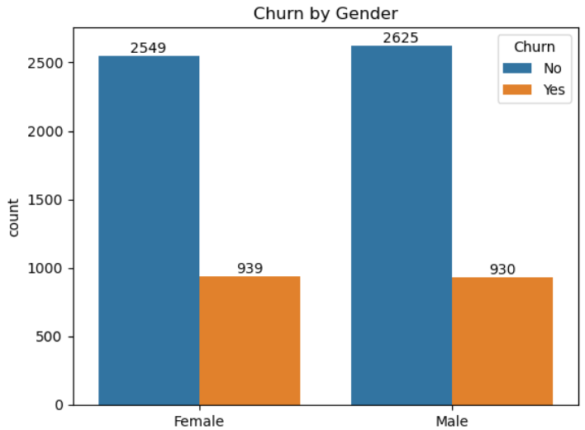

**Senior Citizens**

* **Churn Rate:** 41.68% (from the total of Senior Citizen customers)
* **Non-Senior Churn Rate:** 23.61% (from the total of Non-Senior Citizen customers)

**Insight:** Senior citizens are more likely to churn, possibly due to technical difficulties or unmet service expectations.

**Recommendation:** Develop tailored support programs, provide user-friendly service guides, and offer senior-specific packages.

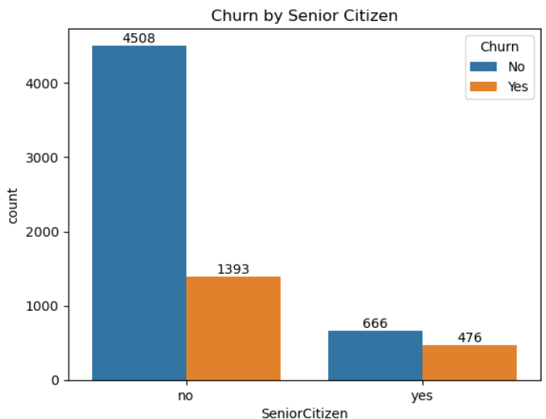

**Partnership Status**

* **With Partners:** 19.66% (Churn form the total of individuals with partners)
* **Without Partners:** 32.96% (Churn form the total of individuals without partners)

**Insight:** Single customers tend to churn more. Having a partner likely leads to shared service usage and lower churn.  
**Recommendation:** Offer partner or family discounts and emphasize shared value in marketing.

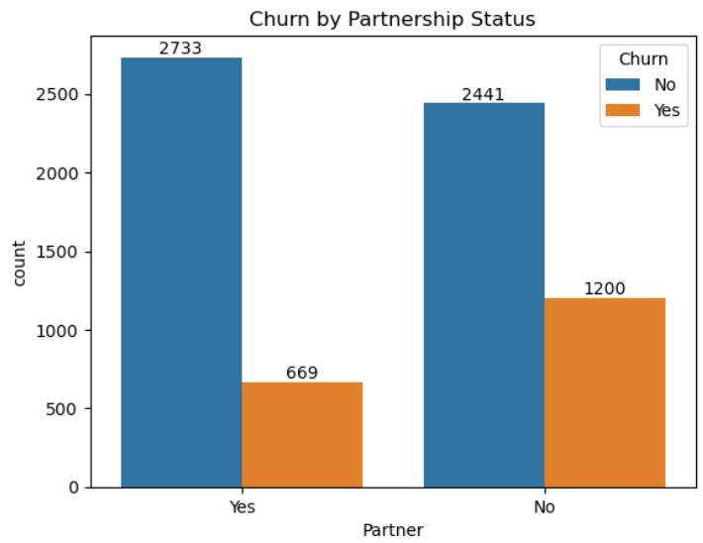

**Dependents**

* **With Dependents:** 15.45%
* **Without Dependents:** 31.28%

**Insight:** Customers with dependents are more likely to retain services, possibly due to family reliance.  
**Recommendation:** Promote family-friendly service bundles.

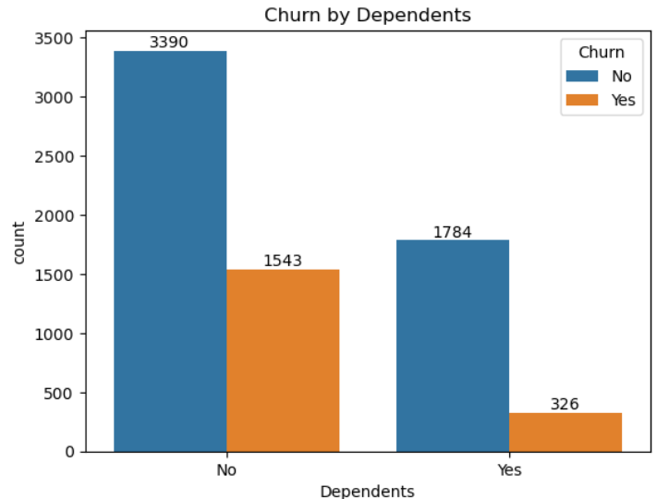

**3. Service Impact**

**Contract Type**

* **Month-to-Month:** 42.71%
* **One Year:** 11.27%
* **Two Year:** 2.83%

**Insight:** Month-to-month customers are at a significantly higher risk of churn.  
**Recommendation:** Provide loyalty incentives, discounts, and exclusive benefits for annual contracts.  
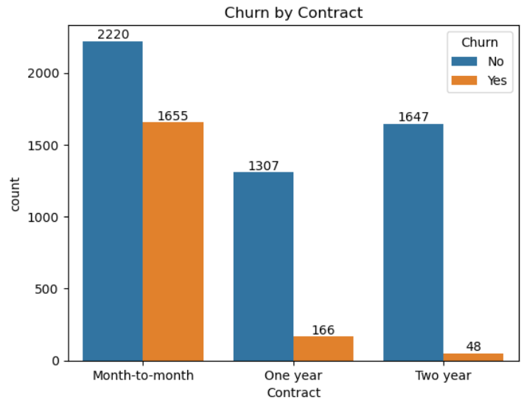

**Internet Service**

* **DSL:** 18.96%
* **Fiber Optic:** 41.89%
* **No Internet Service:** 7.40%

**Insight***:* Fiber optic users show a high churn rate, possibly due to price sensitivity or dissatisfaction.  
**Recommendation:** Address pricing concerns, enhance service reliability, and improve customer support for fiber users.

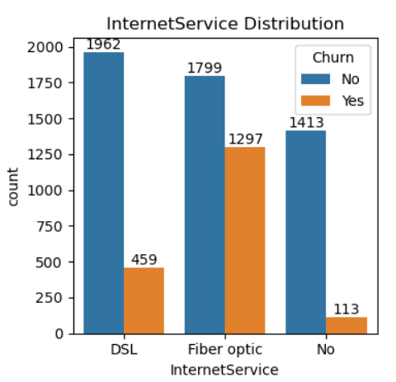

**Tech Support Availability**

* **With Tech Support:** 15.17%
* **Without Tech Support:** 41.64%

**Insight:** Lack of tech support drives churn.  
**Recommendation:** Provide free tech support trials, 24/7 support options, and proactive troubleshooting assistance.  
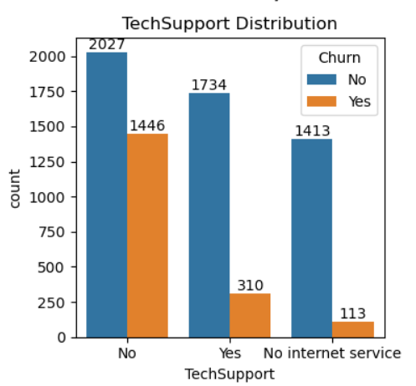

**4. Payment Behavior**

**Payment Method Impact**

* **Electronic Check:** 45.29%
* **Mailed Check:** 19.11%
* **Bank Transfer (Automatic):** 16.71%
* **Credit Card (Automatic):** 15.24%

**Insight:** Electronic check users face a disproportionately high churn rate, likely due to a lack of payment convenience.  
**Recommendation:** Promote secure automated payment methods using incentives and emphasize the ease of credit card or bank transfer payments.

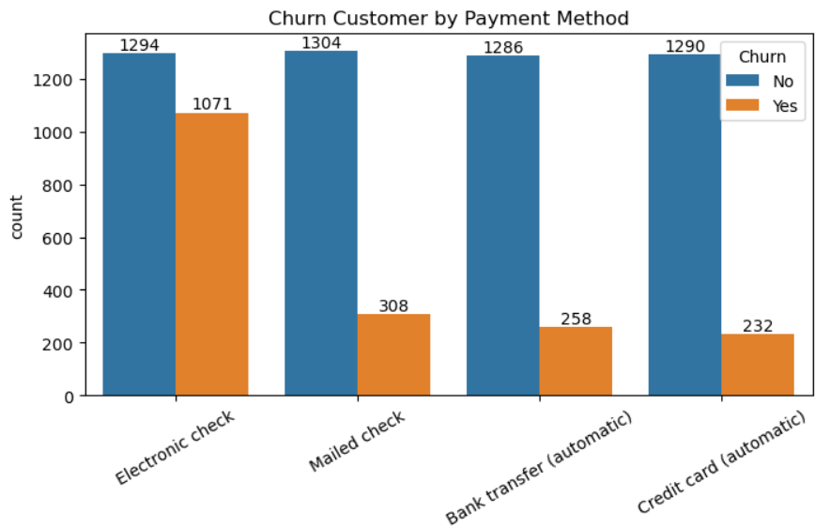

**Key Recommendations Summary**

1. **Enhance Support for Senior Citizens:** Implement tailored customer care programs and create simplified digital experiences.
2. **Incentivize Longer Contracts:** Offer loyalty rewards, discounted annual plans, and additional benefits for long-term customers.
3. **Improve Fiber Optic Service:** Focus on network stability, communicate service improvements, and offer price incentives.
4. **Promote Tech Support Services:** Encourage free tech support trials and offer premium customer service packages.
5. **Encourage Secure Payment Methods:** Provide discounts for using automated payments and offer secure, hassle-free payment experiences.
6. **Introduce Partner and Family Plans:** Offer bundled services to appeal to customers with dependents or partners, increasing retention.

By implementing these data-backed recommendations, the company can reduce churn, improve customer satisfaction, and foster long-term loyalty.